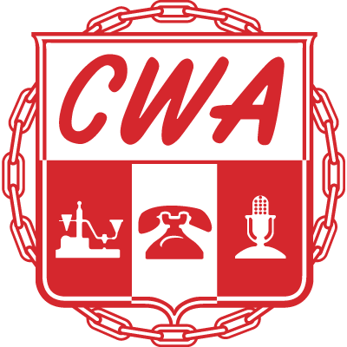

**Local 3905 Steward List**

**Name Department Email Phone**

Michelle Evans DTV Steward [mevans@cwa3905.org](mailto:mevans@cwa3905.org) 719-310-8512

Crystal Hart DTV Steward [chart@cwa3905.org](mailto:chart@cwa3905.org) 256-655-1827

Nikki Crotts DTV Steward [nikki.crotts@yahoo.com](mailto:nikki.crotts@yahoo.com) 256-656-4788

Melissa Bell Secretary/DTV steward [secretary@cwa3905.org](mailto:secretary@cwa3905.org) 561-929-3550

Michael Summers Wiretech Steward [michaelsummers33@gmail.com](mailto:michaelsummers33@gmail.com) 256-631-2271

Michael Linder Wiretech Steward [michaellinder815@gmail.com](mailto:michaellinder815@gmail.com) 256-520-0804

Richard Pallugna Wiretech Steward [rpallugna@cwa3905.org](mailto:rpallugna@cwa3905.org) 919-888-6642

Charles Burns BSW Steward [cburns@cwa3905.org](mailto:cburns@cwa3905.org) 931-637-2371

Cheryl Fletcher Arsenal Steward [cfletcher@cwa3905.org](mailto:cfletcher@cwa3905.org) 256-544-9490

Cheryl Jackson Clinton Steward [cjackson@cwa3905.org](mailto:cjackson@cwa3905.org) 205-478-9174

George Petticrew Core Steward [grouper159@bellsouth.net](mailto:grouper159@bellsouth.net) 772-643-8672

Joseph Ward Core Steward [jbward101@gmail.com](mailto:jbward101@gmail.com) 205-305-7052

Seth Weaver IHX Steward [ksethweaver@gmail.com](mailto:ksethweaver@gmail.com) 256-486-1818

Rob Arnold IHX Steward [bamarob@gmail.com](mailto:bamarob@gmail.com) 256-651-4191

Daniel Jones IHX/Retail Steward [hdcoach78@gmail.com](mailto:hdcoach78@gmail.com) 256-338-6022